Evangelism Thoughts
Sharing ideas, methods, attitudes, related to soul-saving
Joseph Sullivan

Evangelism thoughts
Sharing ideas, methods, attitudes, related to soul-saving
PT 1 - The state of the church/our responsibility
PT 2 - Teacher section: methods and ideas
PT 3 - Evangelism is mentorship
PT 4 - The mindset of evangelism
PT 5 - About the author/ My goals in matters of evangelism.
-------------------------------------------------------------------------------------------------------------I encourage you to use this material in any way you wish, in personal devotionals, in group home Bible classes, in church sermons. These themes can be combined with scripture to highlight church decline, evangelism, mentorship, etc. These thoughts can help a person grow in essential concepts.
-------------------------------------------------------------------------------------------------------------
------------------------------------------------------------------------------------
Part 1: The state of the church/our responsibility
------------------------------------------------------------------------------------
The serious need for evangelism as the church declines.
History shows winter and darkness precedes spring and the dawn. Churches throughout time have never thrived in climates of ease and luxury. The seeds of passion and zeal come from the soil of poverty and persecution. As the US government and economy decline. As rights erode and comforts decrease...the kingdom that is continually shrinking and is being lulled to a quiet death...may begin to stir. I stand on the precipice. I stand with those heralds, those navigators, those visionaries, watching God's house burn. I stand with people who are here at such a time as this...to put out the flames.​
The war in heaven is to be...fought on the earth. Not with a bow or javelin. But with the pen and the sword of one's mouth. Winter is coming. Maybe you are here to help bring in the spring. Maybe you can help keep the US churches alive during the dark days to come. Platitudes and well wishes will keep no one warm in the cold days ahead. Passions burning bright in the night's sky are needed. Fires burning in men's and women's hearts are required. Evangelism ignited from church to church by zealous people is essential. What will history say about you in the pages of heaven? Will you be silent, or will you join the side of the angels? What will Providence's hand, write about you?
Rome lasted over 1,000 years; America has been around for over 200. Yet the seeds that brought about the end of this world power are the very seeds planted in the soil of this fairly new nation. Barbarians may have been at the gates of Rome....but this once great nation has conquered itself long ago. Any nation or people who forget who they are...will lose themselves.
​Campfires are winking out one by one. The night is getting darker and colder. Yet few cries are called out in the watch. I don't know if it will come in my lifetime or not... but when enough people see the signs of cultural decline in the churches of America, a remanent will act, (as saints of different races and languages have throughout history) to try to turn back the rising tide. When faces are turned to heaven for the work of soul-saving...the tide will begin to turn. That is if enough people choose to act. As churches continue to die and numbers shrink, I pray for heroes to join the fight.
When there are more people in the city I live in, (Tampa, FL, US) than Christian in all of the US states, we should be alarmed. When we have lost over 200,00 Christian in our church population in 20 years. When around 52 congregations die per annual turn of each year. When we lose more churches and saints than we grow... we should be in earnest. Yet silence is too often the norm for this crisis. We certainly do need heroes in these times. It is not enough to talk about change, to pray about making a difference. We must act and we must act now. Fires must start, before the last burning light in the night is snoughted out. Evangelism is the cure for this problem. Things can change, if enough churches and if enough saints begin to follow this Bible command.
This world needs heroes. This world needs men and women sounding the warning cry, of Jerusalem's ruin. As the prophets did of old. A call for change (back to evangelism as kingdom culture) and restoration to the old paths. We need "Jeremiah's" giving the warning call and "Nehemiah's" set on rebuilding what is broken. We need "Ezra's" to repair the temple of the Lord. We need the citizens of the kingdom to be focused on God's house, which lies in ruins and prioritize this over our wealth, our homes, or vineyards.
Haggai 1:4 This is what the LORD Almighty says: "Give careful thought to your ways. ... Why?" declares the LORD Almighty. "Because of my house, which remains a ruin, while each of you is busy with his own house. Many have forgotten God’s kingdom-building work, while in pursuit of other things. Life’s blessings have distracted them. See, Deuteronomy 8:1-19.
The walls need to be built in the kingdom. The churches need to be made strong. The old paths of evangelism need to be taught and actively practiced. The Jerusalem of our day, the Lord's church, needs workers. We need leaders, we need them now. We need them to be you.

------------------------------------------------------------------------------------------------------------------------------------------

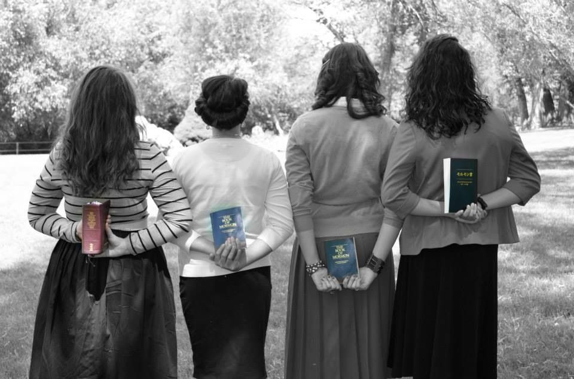
Evangelism culture in Mormons Vs in the Lord’s People
It breaks my heart, that 19-year-old Mormon men and women can quote passages from their book on what they believe and why they believe it. They know their book. They study it 1-2 hours a day. Yet I know of 50-year-old Christians, who've been to church most of their lives... who can just spout John 3:16.
A large part of the kingdom tends to only study their Bibles on Sundays and Wednesdays if they attend faithfully. Which is less than 2 hours of Bible class and less than 1 hour for 2 sermons on Sunday of Bible content...a week. That is if the sermons are preached for 20-30 minutes each. This averages to around 3 hours a week. Which is not much. We eat more meals, sleep more, watch more tv, do more hygiene, etc., then we tend to our souls. How messed up is that. Most Christians can't defend the convictions they hold with scripture, not even if they have a Bible in hand.​
It breaks my heart, that 19-year-old Mormon men and women save their money and put off college to devote a year to nothing but evangelism. They work 5 days a week in outreach. They spend 7 hours a day in door-knocking and Bible studies. They bring people to their faith through the hard work they do.
These 19-year-olds have more evangelism experience with teaching others, than most senior Christians have, in a lifetime of serving Christ. That is including preachers and even certain paid “evangelists,” in the brotherhood. Many Christians have never even bothered to try to reach the lost, to begin with. I include preachers in this category. Too many ministers, preach only to the congregation, but rarely to those who are lost in the community.
Mormons feel an obligation to do these things. They believe the Lord has commanded them to do these duties. A number of Christians believe in Bible study and soul-saving. But not enough it seems to actually seriously apply the concepts the Bible teaches, in this regard. Many saints only give lip service to the Great Commission.
Mormons are proud of their faith. Christians in large part, seem to be silent on theirs. The Church of Jesus Christ of Latter-day Saints has a strong religious culture. Yet we, “the people of the Bible,” the “followers of the NT pattern,” need to strengthen our culture in the kingdom. We can change our culture. It can be done. It must be done.
On Friday, September 10th, 2019, Jehovah's Witnesses had their track rack at Ulles park at Tampa city's bay shore walkway. And at the Crunch gym near my house, they were outside working. During that year, while walking at the university mall, in the Tampa Bay area, I saw that Scientologists had rented a booth and were passing out flyers. While at that same mall.... a denominational minister invited me to his church, (which was inside the mall).
Zeal is everywhere, misplaced as it is. I've seen a lot of outreach...from various groups. Yet I seldom have run into fellow saints doing outreach, in my local area, despite living in the COC Bible belt. I run into Mormons, the Jehovah’s Witnesses, Baptists, etc. The workforce in numbers/consistency is so low, in the Lord’s kingdom, I have yet to run into saints from different churches. It’s not the true church I have seen out canvassing a neighborhood, doing work at the flea market, etc.
So many churches, preachers, saints sing "ring it out" and "I want to be a worker for the Lord," but our kingdom culture rings out another message.
Have you ever had a coc member knock on your door? I have had Mormons and Jehovah's Witness groups do so throughout my life. But I've never had a brother or sister in Christ, knock on my door. We don't have the same workforce out in the community, that these groups have. We are not as visible in the community, as these groups are. This needs to change.
We are not as visible as the Mormons and Jehovah's Witness groups are as a workforce in the community. They have a reputation in these fields. When people think of door knockers, they think of these two groups. Yet when it comes to our kingdom, as a church, too many people don't even know who we are, (as a religious group). These groups are growing, and we are shrinking. The great divide between their culture and ours is in the practice of evangelism.
Evangelism is a verb, not a noun. It needs to be applied, (as it is a divine command). Soul saving should not just be sung, prayed, or talked about. Nothing wrong with the latter, but God seeks conviction and sincerity. One must accompany the other. We have lost a large percentage of our churches in the last 50 years...due to a mentality of inactivity and empty rhetoric in just saying words and not showing deeds. Where will we be in another 50 years?
Mormons and Jehovah's Witnesses have grown in 50 years into multi-millions, for they practice what they preach. We, however, lose more a year than we take in. Yet lectures and articles in the brotherhood focus on anything and everything...under the Sun, then these specific needs we must address. How many gospel meetings or Bible classes do you know of that are outlining the stats of our severe decline?
This epidemic can't be ignored. It must be treated with the urgency it warrants. It should not be a side note in gospel meetings or lectureship events. If it is even dealt with at all. Which too often is the case.​
More churches and preachers need to go beyond talking, they need to be training others, getting folks into the field to train them in onsite mentorship. No one will escape the Lord's anger who sat on the sidelines. Who saw a new convert and never knew their names or talked to them. Who heard (from the Bible on Sundays) the importance of saving souls... yet was always too busy to share Jesus. Our salvation depends on supporting those who have found their salvation and our salvation depends on sharing Jesus.​
If you live in the Bible belt, where you can pick a church, like your favorite ice cream flavor, you may not realize that outside of such places like Texas, Florida, Alabama, most states have less than a handful of churches, and many such churches are comprised of 10-30 members. Most of the congregations are age 60 and up. Watch live videos of most services online and you will see one or two dozen members or so. In churches like California, there used to be many churches spotted up and down the coast. Now, most of these churches are gone. Church pockets and clusters are dying out in the US.
When the elderly die out in a congregation and the youth, grow up and leave, for college or get a job out of state, then that is when the assembly begins to die out. At one point, during the 1930-the 1950s, we were known in the US and we were one of the largest groups in the country. Even as far back as the 1800s, we were thriving.
But that was when evangelism was more than just a Sunday prayer or sermon, comprised of empty rhetoric and platitudes. That was before excuses came up like, "I don't have to work, my church is sending money overseas." These token words and spoken excuses cause members to think this command (to save others) was more optional than anything else.
When the church of Christ people... sit in indifference, praising God, attending church, etc. while they allow their neighbors, their friends, their family members, to pass from this life and be lost forever, what does that say about us, as the people of God? The hell pit is open, when we do nothing, it is as if we are ushering the world inside. We need to remember that the gospel is only active when we are.
------------------------------------------------------------------------------------------------------------------------------------------
For detailed stats on church of Christ decline, see my book “Save a Church from Dying.”
www.churchofchriststreetcampusevangelism.com/church-of-christ-evangelism---free-material-store-page.html
You can also go on your search engine and type “church of Christ decline” or “church of Christ dying” to find the statistical facts about kingdom recession within the church.
------------------------------------------------------------------------------------------------------------------------------------------

Evangelism culture frowns down on apathy
The taboo in certain religions: The Mormons and the Jehovah's Witnesses in their culture view apathy towards evangelism, as a sin and as a repulsive taboo. Indifference in these religious circles to evangelism is strongly frowned upon. When these groups see lax people not doing outreach, such people are viewed as sinning. They are warned to repent. It seems though in this cultural perspective, that the Lord's church, in kingdom culture doesn’t view indifference towards evangelism as a sin. Sure, saints preach on it, teach lessons about soul-saving, they even give prayers on this theme during worship. Yet if this type of apathy was truly frowned upon, would not the culture reflect that? If such inactivity (towards evangelism) was really a taboo and viewed as a serious sin, like adultery, murder, fornication, and homosexuality, would not Christian people condemn such behavior and not remain silent on this lifestyle wickedness?
This behavioral acceptance has spread from saint to saint and church to church. This leaven has become an epidemic. This leaven has infected the kingdom and has become a spiritual disease that is causing the churches in the US, to die out. If evangelism was viewed in the same importance and Biblical perspective, as the themes we disfellowship people over and condemn, (when not practiced) like the Lord's Supper, attending church, being faithful in marriage, etc., we would not be where we are now, as a kingdom in the US.
Many churches in the kingdom want to grow, yet when some of them are presented chances, they decide to decline the opportunity, for it requires...work. A few generations from now...where will we be, if we continue as we have?​ At the rate of decline, we are estimated to cease existing in the United States, in 75-100 years, if not sooner. Things need to change. The tide has turned throughout history, it can change again now, if we are but willing to act. If enough churches step up the tide can change. ------------------------------------------------------------------------------------------------------------------------------------------
What will happen if the church continues to ignore evangelism?
The current state of evangelism is pretty sad, but our current state doesn’t have to be our future reality.
The trends of our past may say one thing, but the trajectory of our future regarding evangelism is fully dependent on our present decisions. What are we going to do next?
If the current trends continue, the church will continue to lose its effectiveness. Our culture will continue to collapse. Our country will continue to decay and decline. Our families will continue to deteriorate, and more people will die and go to hell.
Not only that, but God’s word tells us we will be held accountable for our disobedience and God will remove our lampstand of effectiveness.
Revelation 2:5 says, “Remember then how far you have fallen; repent and do the works you did at first. Otherwise, I will come to you and remove your lampstand from its place, unless you repent.”
​God used these words to warn the Ephesian church that if they did not repent then He would wipe them out as a church. They would cease to exist. The same warning applies to the many local churches that have been called by God to fulfill the Great Commission.
Unless they repent of their lack of evangelistic focus then God will cause them to lose their effectiveness and possibly even existence as a church.
What does that look like in our context? If the church continues to ignore evangelism, then it is highly likely that the future of the church will include fewer people being discipled, a lack of cultural effectiveness in the community, the judgment and wrath of God, a lack of freedom in worship, and lost generations who will live without knowing Jesus.
That phrase “Lost Generation” was coined by Ernest Hemingway and was used to describe the generation of young soldiers who had fought bravely during World War I, but came back home and felt directionless, purposeless, and disoriented.
However, it’s also a term that could be used to describe the church of tomorrow if evangelism doesn’t become a priority. Without evangelism, the church becomes lost and purposeless, and the result will be a spiritually lost generation because no one would have shared with them how they could be saved.
This world needs Jesus, and believe it or not, the world expects followers of Jesus to tell them about Him! Penn Jillette, who makes up half of the famous magic duo Penn and Teller, is more than a famous magician. He’s also a well-known atheist. As he was being interviewed one day, he talked about a moment when someone handed him a Bible. Instead of rejecting the Bible, he took it as a nice gesture from someone who was concerned about his life.
As he retold of this encounter during the interview, the journalists seemed shocked that he would accept such a gift. But Penn went on to say that it doesn’t bother him when someone shares their faith or talks about their God to him. “What does bother me,” Penn said, “is when people claim to know Jesus and love Jesus, and yet, they don’t care enough to tell me about him.” He concluded that interview by asking one of the most powerful questions I’ve ever heard asked. He said, “How much do you have to hate someone to believe that everlasting life is possible and not tell them that?”
C. Lawless said: “So much is at stake here. Millions in North America do not know Jesus. More than 1.6 billion people around the globe have likely never heard of Jesus. Generation after generation of children and young people are following false religions, deceived by an enemy who wants to keep them in bondage.
Families—even Christian families—are falling apart around us. Meanwhile, thousands of churches go through the motions Sunday after Sunday, making little eternal difference. Since 1960, we are reaching no more today than we did then. We can only wonder if Satan would say to us what the demon said to the sons of Sceva in Acts 19:15, “Jesus I know, and Paul I recognize — but who are you?”
Don’t forget what Jesus told his followers in Matthew 5:13-15:
“You are the salt of the earth. But if the salt should lose its taste, how can it be made salty again? It’s no longer good for anything but to be thrown out and trampled under people’s feet. You are the light of the world. A city situated on a hill cannot be hidden. No one lights a lamp and puts it under a basket, but rather on a lampstand, and it gives light for all who are in the house.”
Our evangelistic pulse is faint, and yet God’s word is clear. We are called to be salt. We are called to be light. And if we fail to do what God created us to do, if we fail to be who God created us to be, we will become ineffective, “no longer good for anything but to be thrown out and trampled under people’s feet.”
That’s not what God wants for you and me; it’s not what He wants for His church. He wants us to repent if we have reason to repent. His desire is for us to prioritize the things He’s commissioned us to do, and to pursue Him as we’ve never pursued Him before. I really liked this article, so I shared it here. It is written by J Easley and E Easley. Though I don't endorse what the writers believe in all formats of doctrine. He does make good points.​
------------------------------------------------------------------------------------------------------------------------------------------
Quotes to remember: “On my right hand, I can count how many sermons I've heard about heaven and hell. Brimstone sermons were preached during the great awakening. Heaven's glory was proclaimed. In the 1800s, evangelism was actively held up and practiced due to the emphasis of teaching these Bible themes. Hell, and heaven being preached served as reminders of the importance of soul-saving. In this age of dying churches and evangelism indifference in the kingdom...maybe we need more sermons preached on these topics. Preached regularly. To serve as reminders..."
------------------------------------------------------------------------------------------------------------------------------------------

How to revitalize the kingdom as an evangelistic culture
Almost 10 years of my life have been centered around one main focal point. I know the kingdom is fading. I know of champions who are trying to change that. In any revolution, there must first be a revelation. A seed planted in the minds of men and women that will bear fruit.
If the kingdom is to rise again from its state of decline, we must have heralds. We must have people spreading the word that the churches are dying out and that we in the next 100 years, if not much sooner, will cease to exist in America. If the culture is to turn to evangelism, they need to know the fears of neglecting this cause and the hopes of evangelism, if this ideal is embraced.
We must have navigators. We need men and women to teach people the ways of outreach. Showing methods, lessons, and resources for guidance and stories for hope. I stand with the angels and with those fierce few who are heralds and navigators.
If you want to join the heralds, share this theme that the churches are dying. Let people know the cure for cultural change is evangelism. If you want to be a navigator, create a blog, video, Tweet, Facebook post, social media group, etc., and share ideas on ways to strengthen the kingdom and share thoughts on how to do outreach to grow the church.

I am thankful for those who are raging against the night. For those beautiful lights in this pitch darkness who want to create change. The kingdom needs the heralds and navigators to breathe life back into the fight and make flesh the ideals of evangelism. It's up to you, it's up to me. It can happen. It must happen.
Mission plan: If we saturate the kingdom culture long enough, with relevant themes, even the hardest soils will be penetrated. We need to produce evangelism content or find outreach content online, that we can share with others. Themes that highlight the issues of kingdom decline and the need to do evangelism. People can also share methods, success stories, ideas, etc. Then regularly promote these themes. If enough people share and promote such topics and emphases our accountability in these matters the tide will change. Kingdom culture will begin to become evangelistic again.
Effort plus time will equal change. If we reach enough people, if we are consistent, if this is done long enough, a segment within the brotherhood, that has fertile/ready hearts, will hear the message and join us in this movement. They will become heralds and navigators. They will begin to rebuild the walls of Jerusalem. They will begin the work of evangelism. A penny saved a day is a penny, but if that penny is saved for a week, month, year, decade, lifetime, then it becomes something else. The compound effect for the people of God doing His work, is the same. It is no different. Let us be ever trusting our efforts to Him in prayer.
------------------------------------------------------------------------------------------------------------------------------------------
Quotes to remember: “​Involve the leaders, people will support what they help to create. Try to get members to invest in the work. People will defend, fight for, support and love, what they have been involved with creating."
------------------------------------------------------------------------------------------------------------------------------------------
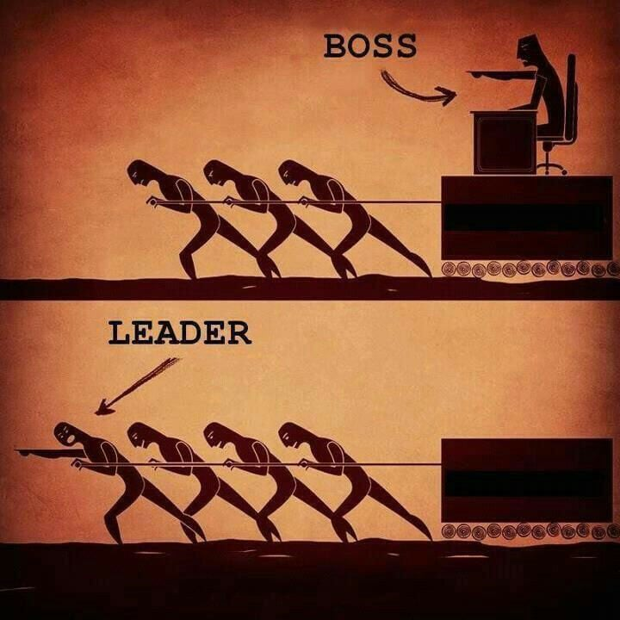

------------------------------------------------------------------------------------
Pt 2: Teacher section – on methods and ideas
------------------------------------------------------------------------------------
A note to teachers who want to prepare their church for evangelism work
Remember to put first things first: Before you introduce a church, or evangelism group to methods, first introduce them to NT stories of Jesus, the Apostles, and the examples from the disciples in the book of Acts. Do this to highlight the right examples and the expectations God has for his people, as evangelism workers. Emphasize such work is our responsibility and highlight the details of these stories and how they apply to us today. Methods can be tied in. But examples that highlight our accountability to outreach are important. Soul saving needs to be shared as part of our moral responsibility as Christians. Methods can come later…
To foster an evangelism culture, promote these concepts regularly. And back up what is being said with actions. All the sermons, Bible lessons, and announcements from the podium will not do anything if those who are promoting these themes are sitting on their hands. Examples are powerful for both good or ill.
Remember prayer. Get your church congregation to pray for this work your congregation is focusing on. When groups are meeting also have them pray for this effort. This helps center the minds of the saints on this purpose and it beseeches God for aid in this work. Let prayer for outreach always be intertwined with the church worship and the group meetings of its members. Let prayer be a part of the work before an event begins and after it ends. Let this behavior be encouraged by the leaders. Let them exhort the members to make prayer (for evangelism) be a part of their daily lives. Let such prayers be encouraged by preachers/evangelists/elders. Let them motivate the saints to regularly pray for evangelism development/growth, for soul-saving opportunities, and to talk with God on concerns and interests they have on this subject.
-------------------------------------------------------------------------------------------------------------

Create investment in an evangelism training class: through inclusion, mission statements, and journals
Inclusion: Have the evangelism group emotionally invest in the group. The more interaction and physical/mental interplay you have the group do, the more invested the group will become. Have group members say prayers, ask them for their feedback on topics given during class, call on members to do activities in the class, like pass out paper, read scriptures, do a role-play exercise, etc. Have the group members reach out and contact someone who is discouraged in the group, to let them know they are valued.
Mission statements: For an evangelism class have an evangelism chart, ask everyone to sign what they want to accomplish in the aspects of evangelism. Have the chart be a mission statement of what they want to become as evangelists. Have them also sign what they want to achieve in evangelism work. Have them sign their full name next to their written goal.
When all the class has done this, compliment them for their desire to serve God in outreach and have each member read what they wrote and praise them afterward, on the ideals they put down on the board. Companies have their staff members put down into words their personal goals and expectations on how they want to improve the company, onto a large company board. They do this to get their members (emotionally) invested in the corporate business. This helps the members be invested in improving the business. They then have this board placed in view where the staff can view it.
See “7 Habits of Highly Effective People” by Stephen Covey, to learn more.
When the evangelism group has signed its mission statement. Have this signed chart placed out in the evangelism group classroom. Also, give each person a copy and text them a copy. Ask them to keep this in a place where they can go to for visiting their mission statement. And to read the team’s mission statements. Writing the statement is an investment, reading it, again and again, is also a reminder of that investment. Reading one’s evangelism team’s, statements also creates a bond and feeling of unity, within the group. Have the mission statement chart framed in the class for the members to see each time they come in. And encourage new members to sign the mission statement chart, as they join the class.
Journals: Have “evangelism journals” for the class. You can buy beautiful, well-made journals, to let the class know you value them, if wished. Personally, give each student a journal. This is best for kindergarten, middle school, and high school/college groups. Adults can be given binders or a folder with paper/pen for taking journal note-taking. The students should be encouraged to take notes, they can even make digital documents to record their thoughts. Let each student know why they are given the journal. Tell them to record their evangelism ideas in this journal, for when a thought comes upon them during the day, to write it down. If they are studying a method and they find something they value, have the journal as a means for them to write it down. And when they hear the teacher speak in the class….something they note worth recording, take the time to encourage them ”to write it in their own words and make it theirs.”
Let the student know they can tailor what they hear to better reflect their goals, aims, and personal ideals in doing evangelism. When a student writes down an idea, it becomes theirs. They own it, they have invested in it. The journal gives them a purpose, the written activities make the evangelism ideas more personal, meaningful, and valued. Encourage the students to read ideas they wrote in their journals during class and always compliment them when they do. Positive enforcement helps motivate people to invest in the journal. Having them feel valued by reading their journals, will also help them to feel inspired to write in their evangelism journals. They don’t have to have physical journals; the goal is to find ways for people to proactively think about evangelism and to make applications on this theme (for their lives).
For myself, I have a journal for evangelism strategies. When I find excellent resources, from successful evangelists, I write down what they did for success. If I find good material online, helpful stats, ideas, etc. I put that in my evangelism journal.
Getting your group involved in class, getting them to do mission statements, and write in the journals, helps them to make an emotional investment, which leads (long-term) to a physical/life investment.
Getting people to invest, helps people to invest again and become more connected long-term into the work of evangelism.

------------------------------------------------------------------------------------------------------------------------------------------
Create structural growth through groups
After saints are trained in methodology and are impressed upon, the personal responsibility they have to share Jesus, they should be given individual things to focus on in doing outreach. And be given encouragement and accountability charts, (see following details, further in next article,) for them to work on. These charts can be used as measuring rods for improvement. The leaders and the team workers can see how someone is achieving in a given assignment and praise that person. These charts can serve to encourage the evangelism workers.
Note: These ideas have been shared by Perry Hall and Ricky Shanks. They are exceptional evangelists. I encourage you to study these men. Brother Perry Hall has put together a goal sheet for creating accountability in the church in matters of meeting responsibilities in kingdom work. The first file is the chart called "Make your Mark." The second file document is an explanation of this content. He's worth studying. Check out this video. These men don’t use names, they just encourage others to make their mark. I believe names help to add accountability. Both work. Figure out what format you like best.
Saints should also be encouraged to do group evangelism activities together. For the evangelism leader, I’d encourage you to create 3 stages of growth for your church members who want to be a part of an active evangelism group work. The 3 stages can be, “Beginner,” “Intermediate” and “Advanced.” As the saints develop and evolve, you can move them forwards from one level to the next. Each level will have a set of team groups. As a person improves they will go on to the next group. But only after they are asked, and the details are explained to that worker, on what the next level will entail.
People need to be trained on how to approach people, how to conduct Bible studies, training should take place in person. The content can be streamed to those who did not make the meet-up, through online live class workshops.
Individual evangelism methods should be taught and explored as well as group evangelism events. For group work...the best way to teach someone is through infield training. People learn best through being on the ground where the action is. People grow best through immersion. That is done when leaders are present for support and help, (if it is called for and needed).
Evangelism should be transitory. That being, it should evolve. Outreach should be a progressive process. A solid work will grow in gaining more leaders, more teachers, more people creating events, more reliable helpers. When this is done, more souls will be saved, and more people...be grounded/taught to save and be incorporated into the soul-saving work, (especially new converts). “More” is progressive. The same old actions being done again and again... is stagnation. Aim for more.
A “Beginner” can be for those church members who are just starting out. They should join a weekly or once a month meet-up “Beginner” group for encouragement, support, mentorship, fellowship, at someone’s home. This time should be a time of reflection, group goals should be discussed, feedback should be given. Food, social bonding are also positive by-products of such meet-ups. This format should be the same for all groups, Beginner, Intermediate, Advanced.
Example goals that can be given to beginning members:
These members can be encouraged (in the beginner group), individually to invite 1-2 people to church each month, or they can get together as a group once a month for an hr. and go door-knocking or set up a booth at a campus to get Bible study signatures. They can set up a booth at other places like a fair, flea market, town weekly festival, etc. This group can choose to once a month meet-up with a Bible study group to do “Coffee shop” evangelism, (reading the Bible in a public place with a few saints). This beginner-level group can apply any evangelism format. But for this group, it should be done in small stages and the introduction to such activities should be done slowly.
Themes of soul-saving should be taught in worship, examples from the NT should be shown. Prayers should be expressed on this theme. The leader should mention this ideal often in the assembly and without, (through whatever means a church uses, newsletters, email, etc.) The church needs to have its minds and hearts prepared for work.
When it comes to evangelism work, (within a group) to show appreciation and build camaraderie, reward that team (and yourself) with grabbing a bite to eat after an event. Eating with people is powerful. Food can build bridges, that no beam or mortar can build.
An “Intermediate” church member can be someone who has gotten to the comfort level and experience threshold, (it may take weeks, months, or even a year,) to do more than one evangelism event activity a month. For this person, add them to the Intermediate group’s evangelism schedule. Instead of doing one event, this group will do two. Or the time will increase instead for doing outreach events. If it’s inviting people to church or a Bible study, that number can also be increased. If the group member is ready and willing, encourage that member to attend a new convert class or a non-Christian study. This will help that person get a feel for that class and to get ideas on how to teach a class.
An “Advanced” church member can be someone who has gotten comfortable and experienced enough to be given leadership positions in this field of work. This should begin to happen to those who are in these groups. Doing infield work will train people and help them become confident. Especially as the work and the time invested into the work progresses. Seek ways to train people to become leaders. Seek ways to mentor people and help them grow. Like the intermediate group, the level of events or the time invested in an event can increase. Also, personal invites should be increased as well. We are either growing or dying. Stagnation is a deterrent. Seek ways to help people grow. If the group member is ready and willing, encourage that member to attend a new convert class or a non-Christian study. And when ready to help teach that study, include that person in this as well. With enough time, this person will be ready to lead the class entirely.
In all groups, encourage the members to go to the evangelism group meetings. Praise the work you see a member doing. If you see a talent or special knowledge in the area of evangelism, work with that individual. Talk with the leaders of the church. Ask them to give that person chances to grow in that talent or to share that special knowledge they have, in the work of evangelism.
------------------------------------------------------------------------------------------------------------------------------------------
Accountability chart
Have the church or an evangelism group create a chart. This chart will have everyone’s name on it. For each person who does the listed evangelism assignment on the chart, they can sign their name. The chart can be changed every month. The goals can be for the church as a whole or more specifically for an evangelism group. These goals can be written on that chart. The specific outreach activities/events can be laid out. If someone does one of those activities they sign their name. This helps to foster accountability and responsible behavior. If a person is assigned to invite 2 people to church that month and they sign it, it lets the leaders know that individual is participating. This action helps the leaders get a feel for whose doing what and how much support the church is giving to evangelism. Having an accountability chart will help give the leadership feedback and encourage responsible investment from the church members. It’s good to have the announcer promote this chart, as well as the elders and preacher. The church/group members should encourage and praise those who met the desired goals for that month. Encouragement is air to the soul. Sincere words and positive affirmations can edify the evangelism worker. This can help people feel invested in the process.

------------------------------------------------------------------------------------------------------------------------------------------
My personal format for teaching
For teaching a class for new converts and non-Christians. This format can also be used for regular Bible studies with saints.
I like to use a Bible lesson book or some teaching resource. I try to have the group sit around a table or in a circle with chairs. As a teacher, I make sure the students have the lesson material, a Bible, and pens/paper available, (for note-taking, if wished).
I open up the class with prayer. I try to use one of the church members or new converts. Before we begin prayer, I ask if anyone has any prayer requests. Yes, this can lengthen the time of the meeting. But when non-Christians, new converts, and even evangelism members share their concerns, it helps to bond those people to the group and the hearers feel more closer to the group as a whole, too.
Prayer and Bible study should go hand in hand. God wants us to speak to Him. This example before Bible study sets the right tone for the class. When the students if they wish to have some personal concerns shared, I have a pen and paper ready to write those interests down. If someone else is going to pray, I encourage that person to do the same.
When starting the class, I review briefly what was covered during the last class period, then I introduce the beginning content of the new lesson the Bible study group will be covering.
Once I introduce the content, I go around the table, or circle and have each person read a part of the written lesson. It does not have to be lengthy, just a few paragraphs. I ask that person after reading, the material, certain questions related to what was read. I may ask other students. Especially if the reader needs help with the answer. I also involve the students, by asking them questions and asking them to share their thoughts on specific themes that are covered throughout the lesson. Interplay and interaction are important for Bible studies. It gets people to think, and it helps them emotionally invest in their studies.
When going around the room, I have each student read a part of the lesson. We steadily move through the curriculum. After the first person reads, section A, then I have the next person read section B. If there are written true/false, yes/no, or fill-in-the-blank questions in the lesson material, I ask the students to answer the question when we get to a certain area that has such content. I try to involve everyone. The study in itself, I try to just keep to an hour. I like to use interactive material that has true/false, or fill-in-the-blanks or yes/no responses in them, etc.

-------------------------------------------------------------------------------------------------------------------------------

My Free Bible study materials:
For further info on the material, I like to use, please see my evangelism material resource links below. The content is free.
At my first link, I have my Bible study lessons made for easy use. I tailored them to work effectively with non-Christians and new converts. I’ll outline how to use them in the first link that details this content.
- The Bible study resources I made/use for non-Christians and new converts:
www.churchofchriststreetcampusevangelism.com/my-free-bible-study-lessons.html

- Other excellent Bible study resources from the brotherhood:
www.churchofchriststreetcampusevangelism.com/useful-evangelism-resources.html

- My “how-to” lesson books for learning evangelism themes. Also, I have Bible lessons on scriptural authority, church worship, etc., that can be used in Christian study groups or for one’s personal Bible study.
www.churchofchriststreetcampusevangelism.com/church-of-christ-evangelism---free-material-store-page.html

------------------------------------------------------------------------------------------------------------------------------------------

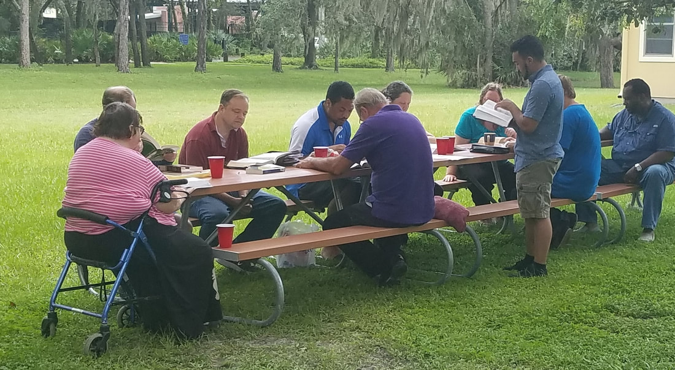
Teaching example story:
I knew of a lady who went to church, she wanted to share Jesus with her community. We (an older man in his 70’s named, Jack Adams and I) went with our sister in Christ, (Laurie Matthews) to each door, (door knock). We’d give them a paper that had an invite.
The invite would have a warm invitation to study at such and such time and such and such day each week. We’d sit outside in the open, where people could see us and invite people walking by to join us in the studies. The visibility, the consistent studies, especially in a poor apartment complex, where most did not have cars or jobs, etc., made this a high success. We had about 9 conversions through this work.
This is a picture of a new convert/Non-Christian Bible class being done outside at an apartment complex. I have 3 other people helping me, (an older man named Jack Adams in a purple shirt, a young man standing up, and a man with a silver watch, a blue shirt at the far right end of the table, Reggie Cheaves). Some of the men were learning to teach through attending the Bible meetups and through being included in the teaching of the lessons. While in this group, these men had support from seasoned teachers.
If you want more details see my evangelism journal at https://www.churchofchriststreetcampusevangelism.com/church-of-christ-evangelism-blog-journal.html

------------------------------------------------------------------------------------------------------------------------------------------
How to train others to become teachers
Inclusion is important to mentor people into leaders. Nothing comes from osmoses. If someone wants to learn how to teach, include them in the homes of saints, when they do Christian Bible studies with the members of the congregation.
If they feel ready, also include them in new convert classes. And when they feel comfortable, include them in a group or small teacher one-on-one study with non-Christians. As they get used to being in such environments and as they see your teaching method practiced, begin to encourage them to help with the study. It can first be with leading a prayer before class or in teaching a small part of the segment of the study. As they acclimate include the person in more and more of the study. With time, as they learn from watching you, and from being a part of the group, and as you give that person advice on how to teach, let that person begin to teach a class.
Teaching others to teach model:
The transition is best done by having interested members (who want to teach), join a training group for this purpose. Have about 3-6 members in one of these training groups. Each meeting have one member teach one of the lessons. Afterward, let the group leader publicly compliment that person and privately (with tact) give personal feedback on how they did. Highlight the good points, diplomatically mention how that person could do better. The positive examples of the leader when he teaches, and that of the other members, will serve to reinforce positive teaching behaviors. Obviously, for the sisters in Christ, a group should be created for them. A woman can lead such a group. We want women to be able to teach non-Christians as well. Sharing the gospel is not just reserved for men. The great commission is for all of God’s people. In each class, have each student do each lesson and fill out all the questions, that the Bible lessons has. As the students practice teaching and get familiar with study lessons geared for non-Christians and as they get used to teaching the new convert materials, they will become confident and knowledgeable in the teaching content and in the modes of teaching others. As they progress in this format, they will, (with time) become ready to teach non-Christians and new converts. This process is an excellent transitory format for taking the next step. That being, attending non-Christian/new convert studies and (with time) helping to teach those students, in these Bible studies.
------------------------------------------------------------------------------------------------------------------------------------------
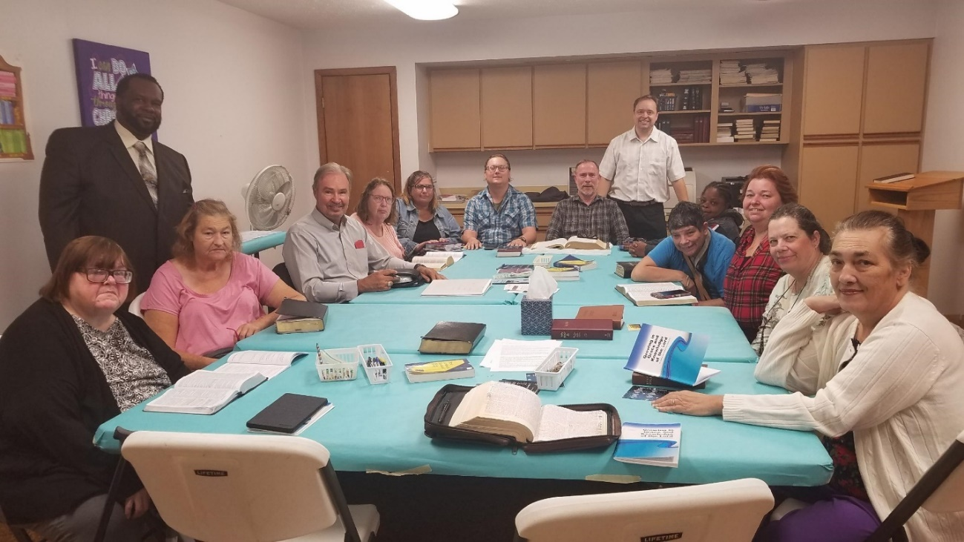
This picture shows a new convert class that was done at the church I attended. I have 2 men, (first man is on the left, standing up, with a black suit, the second man is older, he is also on the left, he has a gray shirt, with red “dot” on shirt). These men are in the class. They are helping me teach. We rotate each lesson. The lady on the right with a red/black striped shirt is helping the female new converts find Bible books/verses. She is quietly helping answer some questions they have, that the class teacher may have missed. We also have had other teachers in the class to help train them.
We had a young college student who was trained to be a new convert teacher. This young man learned how to teach, through doing this format at this church building. This format helps the teachers get better invested in the students and helps keep the teaching/teachers diverse. This format helps to get the new converts to know more people and get invested in those they interact with. And vice versa. This practice was done during the Bible class hours on Sunday morning and Wednesday night. We got two new convert classes done at the building each week through doing this teaching format and by focusing on this process. This work mentored those who wanted to learn how to teach and trained people/acclimated them to outreach work.
------------------------------------------------------------------------------------------------------------------------------------------
------------------------------------------------------------------------------------
Pt 3: Evangelism is Mentorship
------------------------------------------------------------------------------------
How to create an evangelism culture in one’s local congregation
Here is a key phrase to imprint on one’s mind, “evangelism is mentorship.” In evangelism find ways to mentor people into teachers, workers, outreach event coordinators, and leaders. The best way to ensure evangelism thrives in a church is by creating a "multi-head Hydra." If one (evangelism) leader gets sick, dies, moves to another town, has to stop for personal reasons, falls away, is out on vacation, is distracted with the birth of a newborn, etc. the other evangelism leaders can keep the torch going.
In regard to evangelism, encourage other members within the church, to grow in this field, to use their imagination in generating new and creative ideas on outreach, to talk about ways of sharing the gospel, to teach others in classes, to do outreach work, to create their own venues of evangelism projects. Encourage them to have "evangelism journals" to record their idea and thoughts. Innovation must be fostered in the church. Self-reliance and initiative in matters of evangelism must be supported, nurtured, and praised.
Such industry must be tenderly watered and given sunlight, through encouragement. Even those who are not interested (in evangelism) may become interested later on and choose to join in this work if they are given opportunities for inclusion and support. If a leader sees someone with a certain talent, they should use that person and take advantage of that talent. Don't wait for change, unless you are willing to cultivate it.
Remember “evangelism is mentorship.” When doing evangelism events, the leader(s) will have opportunities to create an environment of mentorship and support. They can foster (through one on one nurturing/training) the ready spirit (in the church members) to lead an evangelism event. It’s easiest to work with those who have gone to these outreach events. While there, the leaders can help them develop in outreach work.
Those who show up, can (with time) as their comfort level and experience rises, be motivated, and encouraged to do events themselves. When they are ready to set up an event, you can show up to help them or accompany them as they are putting on an event, so as to be a moral support. This process is best done by using the students in the evangelism class who are showing an interest in such work. Through their growth and as their comfort level increases, encourage them to step up. These things are important to building a well-established evangelism culture.
Types of evangelism events. An event can be centered around doing Bible studies at fast food places, or coffee shops. Outreach work can be done at campus areas, where a booth can be set up. People can go door-knocking. Yes, this activity requires time/work, but if the time/work is put in, the results will follow. Bible studies can be done through street evangelism. Individual saints can invite people. The leaders can challenge the congregation to invite people. The leaders can ask the church members to set a goal each month, of inviting a certain amount of people to services or to a church group Bible study/or a study with the preacher.
Teachers should host classes on evangelism, (to train others on how to teach the lost and to equip people with outreach skills and methods). This format will create an evangelism culture, through mentorship, that supports and fosters the saints in growth. This process helps God’s people to learn how to serve in outreach and to teach others when the time comes (down the road). When I teach someone to teach, they in turn will be able to teach others.
Creating evangelism culture: when there are multiple groups teaching evangelism concepts and doing outreach work, then that is when evangelism will more quickly, become part of the church's culture. We need to train more people to teach and mentor. We need to train more people to be leaders in doing evangelism events, for the church. The cycle of evangelism growth in the culture of a church comes from creating more leaders who teach and do evangelism work. The more people that are teaching evangelism classes, doing evangelism events as well as other group outreach member-oriented activities, the more evangelism will trickle into the church as part of the overall culture. This is most effective if the elders/preacher/leaders support such work in attendance and in their actions.
If people are mentored and trained, evangelism will become a cornerstone of church culture. This is most effective when the leaders are leading in this (cause) as well. When the elders share evangelism materials and continually voice the need of doing this “as a church.” When the preacher is present in outreach work, and is willing to do Bible studies, and is consistent, (at least once a month), in writing articles, and giving sermons on evangelism...then that helps to acclimate the church’s climate and culture for evangelism.

------------------------------------------------------------------------------------------------------------------------------------------
Quotes to remember: “A new testament church is an evangelistic church. A new testament Christian does evangelism."
------------------------------------------------------------------------------------------------------------------------------------------
Mentorship is part of the evangelism process
​Evangelism is mentorship. Church culture can only thrive in evangelism when people are trained as teachers, as leaders, as workers, as event organizers...in outreach. This involves mentorship. A man can break a stick, even two, but a dozen sticks...are harder to break in half. A church that has a few carrying the burden for all in outreach will falter when those who carry the burden stumble. A church that equips many through encouragement and through fostering personal growth in others in outreach, will slowly saturate the congregation's culture with evangelism.​
Paid evangelists, paid preachers or elders sometimes view themselves and those in “high positions,” as the only people who should be fostering/promoting/leading outreach work. For financial and security reasons they view others who actively foster/promote/lead in such work in a church to be a threat. This perspective makes certain men in positions of power uncomfortable and passive-aggressive. This behavior creates tribalism, (that of one person following one individual, while another person is following someone else as a leader of different camps/distinct factions).
If a brother wants to promote the values of Christ in creating an evangelism event and it is met with antagonism. That brother will either leave or persevere in these NT ideals of sharing Jesus. Tribalism occurs when that well-meaning brother gets people involved, some support it, while another follows a more accepted person, like a paid evangelist, preacher, etc. in the evangelism work activities they are doing. Instead of the leaders promoting evangelism as a role the whole church community should take responsibility in. The initiative in promoting/generating such work becomes position-oriented around the designated elder, preacher, paid evangelist, etc.
This mindset hurts evangelism culture. If members have to get the node before doing outreach. If they are looked at as usurpers for getting a Bible study together or a door-knocking event, this damages the initiative of the church for doing outreach. We need to understand that all (of God’s children) can be leaders, teachers, workers, in the fields of the Lord.
Evangelism should not only be fostered/promoted/led by the elders and paid people in a church position. If it is, the very saints who should view soul-saving as a team effort will begin to look at those who actively hold up evangelism, (outside of these designated/self-appointed groups) as usurpers of the paid evangelist and elders. The behavior of tribalism is dangerous. With time it leads to factions within the church. This territorial behavior hurts the evangelism culture of the church.
If someone wants to teach an outreach class, do a soul-saving event with friends from that congregation and that is met with backlash or undermining, this stifles the spirit of evangelism within that local congregation. Leaders need to not look at people as threats but as brothers and sisters in Jesus Christ. They need to not see enemies but God’s family.
We are all playing for the same team. It’s Satan and the world we need to fight against. When the devil poisons people’s minds with money issues, fears, insecurities, power interests, people can be his vessels to undermine and undercut spiritual work within the church. When only the paid preacher or evangelist or the elders are fit to organize, teach, get events and activities together to promote soul-saving themes…stagnation will follow.
When talented people are in the church, who can be mentored, who are hungry to grow, who seek chances to be used in evangelism, but these people are ignored, because they are not some paid person or church elder, this is sin. God wants us to foster workers in the kingdom and to encourage people to evolve in this needed work. Power games, exclusion, undermining, passive/aggressive attacks from people, have no place in evangelism. I’ve seen this time and time again. It breaks my heart.
If you see a young college man with the potential to teach, use him. If you see an older woman with a warm caring heart, (in how she interacts with people), get her involved with the new converts. If you see a family given to hospitality, encourage them to open up their homes for Bible study. If you know of a teen who was getting events together in the past, ask "how can we support such future work?" If you see a young girl or boy that shows interest, (in outreach work) get them involved in evangelism, (with the parent's permission). The younger they start the better. This activity will further help intertwine evangelism into their character as they reach their adult lives.
When mentorship is done...personal accountability is created, and proactive behavior becomes a part of the church dynamic. Mentorship, if it is done to foster growth in others... will cause an evangelism attitude that will trickle down into all aspects of the church. Mentorship is fundamental in getting people invested (in outreach) and in getting people growing/maturing...in His work. Imparting Biblical-based truths as mere words will build a weak foundation. Imparting Bible-based truths as actions through discipling people into the ways of the Master, will build a sure foundation upon the Rock.
Evangelism is mentorship. Every "Paul" needs a "Timothy," and "Silas." The role of the Christian is to teach others and train those taught to teach others. This is circler and should continue as a teaching process for the saints to ground, equip and mentor. As 2 Timothy 2:2, says, "And the things that thou hast heard of me among many witnesses, the same commit thou to faithful men, who shall be able to teach others also."
This is especially important with new converts. Let me share a personal story here...
Story of Rabbits:
On a clear blue day, a few years ago, I was outside. I was mowing the backyard on a sunny hot day in Tampa, (FL. USA), I happened to disturb a nest of baby rabbits. I was surprised. But not as much as these baby bunnies were. These furry rabbits ran around in terror, afraid of the lawnmower. On and on they ran till they were on the other side of the house, huddled against the wall of the building. I mistakenly assumed the baby rabbits would go back to the bush where their nest was. The wall where the little rabbits were...was next to my bedroom wall. Early in the morning (or very late at night), I heard something that woke me up. I heard screaming. Screams of fear and screams of pain. Then I heard silence. The screaming stopped. The baby rabbits were too scared to leave that little area next to the wall. And without the safe protection of their home in the bushes, they were out in the open. An owl...or some other night predator had got them. I will never forget those screams.
Too many times new converts are saved and are then left to fend for themselves. They have no new convert class at the church, they have no one interested in them enough...to spiritually work with them. Too many new babies in Christ are being left in the "dark woods" to die...
Mentorship is a must for new converts. We must be training them; we must be setting the right Bible-based standard and example. We must be willing to befriend them. We must be willing to equip the new converts in the work of the Lord. We must include them in spiritual acts of service, to help them grow in God's truth and work.
What is salvation? Is it having someone come forward and do the things to die and join with Christ? Yes, but it is so much more. It is also found in... helping them walk in newness of life, (Rom 6:1-4).
Teaching truth does not end with their conversion, that's when it really starts fully. Now you introduce them to the "salt" and "light" of Christian examples, (of the church members, of your spouse and family, as well as from your own life). Now you have them incorporated into the church's culture of Bible-based work and service. Now you help them mature and grow up into the Head, (of Christ Jesus).
Evangelism needs to be taught regularly from the pulpit, at least once a month, and those promoting it need to lead and actively do evangelism. Leaders who don’t set the right example, and tone for the church affect the church culture as a whole. Hypocrisy, indifference, is noticed by the members and such behavior influences them. Influence trickles down from the top.
------------------------------------------------------------------------------------------------------------------------------------------
The tale of two paid preachers
I once knew of a preacher who weekly taught evangelism classes; he’d also do interviews with evangelists from around the country. Yet he’d say outreach was not possible for him, he was too old, tired, etc. This teacher and leader also made excuses for the other preacher at that church, saying that the guy was too busy with sermons, etc. to do outreach. Despite the multiple “soul-saving” training classes, evangelism did not take root in this church. Yet another preacher taught evangelism once a month, during church service. This man regularly promoted evangelism themes. He got the church members together to get Bible studies set up at fast food places and coffee shops. They also met at people’s homes. The second guy was out there with his wife actively doing the work and this leader put into place venues to help facilitate outreach activities with the members of that local church. The elders supported and promoted the themes of evangelism. The second evangelist grew the church and got the members of that congregation on board with doing outreach. Examples are powerful. Especially when it comes from the leaders. Attitudes both good and bad can affect church culture.

------------------------------------------------------------------------------------------------------------------------------------------
Biblical teachings on training/helping others
​We need to disciple others. We need to mentor
To those who coach a little league sport, or run a company, to parents who spend time raising children, or to women who head up a girl scout meeting, you have been in the role of the “mentor.” This term (mentor) holds great weight in its capabilities of molding lives and in instilling positive habits. Did you know the origin of mentorship is Biblical in principle?
God speaks of the virtues of mentorship in Proverbs 27:17 when the passage states, as “Iron sharpens iron, so one man sharpens another.”
We think of a karate teacher being a mentor or an influential and caring high school teacher as a mentor. Many of us can look back at individuals in our lives who have helped us to become the people we are today. The word “mentor,” as we think of it today was given a different name 2,000 years ago. The work of mentorship is the same NT ideal we can read in the Bible for discipleship.
Discipleship in NT Greek is mathētḗs (μαθητής). This term means “one who engages in learning through instruction from another.” Other terms for disciple are “pupil” and “learner.” https://biblehub.com/greek/3101.htm
A cooking class can “disciple” you into a better cook. A personal fitness coach can “disciple” you in diet and the best workout routines and exercises. When we look at the storyline of Jesus, we read of a spiritual application to this term called “discipleship.” To mentor or disciple, a person is to mold someone into a certain way of being. No one goes to one workshop and has all the answers in any given field nor does one immediately change into a better version of themselves in any area they are pursuing for self-development. Discipleship in any area is a process.
What is spiritual discipleship?
In matters of spirituality, the Bible speaks of mentorship in two instances in the following passage... “But now, LORD, you are our father. We are the clay, and you are our potter. All of us are the work of your hand.” Isaiah 64:8
We are told God mentors us as a father does with his child. All parents know they have a special role in their children’s lives. They can teach, guide, and live as role models and as examples to their.... offspring. Mothers have a special role in working with and nurturing the family unit.
The father has the responsibility to lead and shows support for those family members in the house. Parents can form, (for better or worse) the character of their children that can last a lifetime. In this serious venue, let us look at the passage again.
What other discipleship traits do we read? God calls Himself the potter and us the clay.
​If we allow ourselves to be soft in our hearts and yield to His will, the Master craftsman can mold us more into His likeness and image. But how does God mentor us (as a father) and mold us (as clay)? Our Lord has given us the Word to disciple us as pupils and mold us into His image of holiness, (2 Peter 1:3-4). When we look at the storyline of Jesus, we read of a spiritual application to this term called “discipleship.” To be Jesus' disciples we must abide in His truth. As the Bible says, "To the Jews who had believed him, Jesus said, “If you hold to my teaching, you are really my disciples." - John 8:32
We are commanded to make disciples for Jesus, to baptize and teach them His truth. - Matthew 28:18-20. This is our purpose as Christians. This is our "great commission" and mission for our lives.

------------------------------------------------------------------------------------------------------------------------------------------
A leader needs to make leaders, not followers
Get the evangelism group/interested church members to commit to helping with a study or evangelism event, the more they commit to the more likely they will commit to further things. If you can get one person to say yes to helping with a study, that individual is more likely to say yes, the next time. If you can get a church member to help with a campus evangelism event, that person is more likely to say yes the next time.
​
The goal of evangelism is mentorship. The goal of leaders is not to create followers, but leaders. Yes, in the short-term new members in an evangelism group will be codependent. But as a leader works with the group, as they become comfortable and evolve, the leader needs to encourage them to take roles of leadership. He should show them how to set up events, teach classes, by having them accompany him to such activities, then slowly aim to get them more involved in the process of event creation and class teaching.
The Bible’s word for disciple means to create a follower. The word is interchangeable with the term mentor. We are to mentor people/disciple people into the pattern/teaching of Jesus. What did our Lord do while on the earth? He told people to “Come, follow me,’ Jesus said, ‘and I will send you out to fish for people.’ At once they left their nets and followed him.” - Matthew 4:19-20 To be a follower of Jesus we must seek to save the lost.
How did Christ disciple/mentor people while on earth?
During ministry, Jesus trained His Apostles, and disciples, (Matthew 5:1-2) in the work and teachings.
Christ showed the disciples His example and included them in His life. When our Lord taught the crowds, (Matthew 23:1-4). When He prayed, (Luke 11:1). When Jesus did evangelism work, (Matthew 4:18-23).
Jesus later sent the Apostles out 2 by 2 with the 72 disciples, (Luke 10:1-16), to do evangelism.
When they got back the Lord Jesus worked with them some more, after doing this outreach work, (as the details of the gospels highlight in its timeline).
Once the disciples had been shown the truth and had accompanied Jesus (seeing His example) when He did outreach and other spiritual activities, Jesus encouraged them to go out and try these things themselves, (Matthew 10:1-42; Luke 10:1-24). Our Lord even asks Peter to do step up and do spiritual things after the resurrection, (John 21:15-19). Discipleship is about fostering a sense of accountability in doing Christian work. It is about encouraging new Christians to step up and do more for the Lord, as they grow and mature in the Word.
When they were ready, He said to them, (upon His departure to heaven) in the Great Commission to go out and make disciples, (Mark 16:15/Matthew 28:19-20). He wanted these followers to follow His example, of being a servant, (John 13:15). As disciples of Christ, we are supposed to do this as well.
Discipleship is about fostering a sense of accountability in doing Christian work. It is about encouraging new Christians to step up and do more for the Lord, as they grow and mature in the Word.
If the only leader in evangelism is the paid preacher or paid evangelist, what happens if one of them gets sick, falls away, is out of town, has a family emergency, moves to another congregation, etc. Well, that church is back to square one. The more leaders a church creates, the better is its future. The more selfless men/leaders who have this mode of thinking the better. When such men are willing to place others in the position of authority as leaders in mentorship, they are helping the security of a congregation. And are ensuring its future.
Also, the more evangelism teachers, event (outreach) creators there are... the stronger and long-lasting the evangelism culture will be.
Let me share this as a quote: The best leaders are not focused on creating followers, but leaders. Followers, only follow, as long as they have a person to guide them. When we create independent, self-reliant, responsible leaders, we do more than “give a man a fish for a day, we teach a man how to fish, and thus feed him for a lifetime.” Yes, we all begin as followers, we are dependent, we must look to another for guidance...for a time, while we are getting our footing. But a good leader, encourages others to develop to the point where they too, can lead.
Jesus looked for opportunities in matters of evangelism. A key phrase I think of when I work with new Christians or possible future saints is this, “discipleship is mentorship.” It reminds me of the (spiritual) role I must play in the lives of those I interact with. As a mentor, I must instruct others and give an example for emulation and guidance, (in matters of the truth). ------------------------------------------------------------------------------------------------------------------------------------------
​​
How to foster evangelism with young Bible students at church
In your middle school and high school and college-age classes have the students be assigned Bible themes to teach. Break the class up, into parts. Have the males and females separated into two distinct groups. For each group, rotate each student to teach one of those classes, (according to their sex) for each (separate) class meeting. Encourage and praise the student after giving a lesson and have students say what they liked about the lesson given. This will turn them into more serious Bible students as well as cultivate in them an appetite to teach from the Bible. Encourage the students to invite their friends on the day they choose to teach. Souls can be saved by doing this activity.
To cultivate evangelism in these classes, when you rotate each student, have them all do an evangelism theme. The theme can be about ways of doing evangelism, what the Bible says about the lost, or the need for soul-saving, or ideas of sharing Jesus, etc. Again, praise them after they give the lesson and ask the class to share what they liked about the lesson. This will foster an interest in evangelism and in talking about it.
This process will get the students emotionally invested in evangelism work.​
The next step (after some time has passed) is to invite your class to an evangelism event and to take them out to eat afterward as a reward for their efforts. Make the event fun and easy to do. They are just kids; the goal is to get them exposed to doing outreach work and to get them involved. Give them positive enforcements like praise and have a group bonding event afterward.
Remember what I wrote before: Evangelism is mentorship. Every "Paul" needs a "Timothy," and "Silas." The role of the Christian is to teach others and train those taught to teach others. This is circler and should continue as a teaching process for the saints to ground, equip and mentor. As 2 Timothy 2:2, says, "And the things that thou hast heard of me among many witnesses, the same commit thou to faithful men, who shall be able to teach others also."
------------------------------------------------------------------------------------------------------------------------------------------
------------------------------------------------------------------------------------
Part 4: The mindset of evangelism
------------------------------------------------------------------------------------
Record your evangelism activities
Know your goals. See the end result of success in mind. Take the time to record the work. Watch yourself grow as you progress to your aims. See yourself mature as you study your recordings.
Write down your dreams, goals, aims, hopes, for your work as an evangelist. The first part of doing the work is knowing what you want and figuring out what it will take to get there. Written goals should be reviewed often for motivation, introspection, review. These written words can serve as a mantra to remind you of what you want to achieve. Pray when reading the list for God to help you in these themes you wrote down. Look for and seek out opportunities to grow in the themes you wrote down. Seek people and resources to help you with those themes.
Record your work as measurements of success. Learning curves only serve to help someone if they record what they learn. If plan A. worked better than plan B., recorded the reasons why. If you had to work for such and such a time to get such and such result, record that. If you had to talk with 35 people on campus before getting someone to sign up for a study record that. If one method worked better than another method, record that.
Once you learn the patterns that lead to success, you can do those specific patterns again and again. The secret to success is to look at work as play, to look at duties as hobbies, to seek to enjoy the process, and make the activities rewarding/fun. When you love the process, you will grow. Given enough time and investment to a cause and results will follow. All a person needs to do is to be willing to learn, grow, record their work to find positive patterns….and to learn from their mistakes. Fall in love with the process.
Make markers for success. Learn what needs to be done to get the best results. Learn the amount of time you need to give to get a result. Record different types of methods. Record the hours worked, the numbers reached, the things learned, the successes to replicate, the stats that lead to results. Create data as benchmarks for success. Find the winning patterns that can be reproduced...again and again. Study those who have gotten results. Research online resources that look promising. Be continually looking to grow. Pray for God's guidance. Always seek opportunity. Be thirsty to learn more.​
​The truth is evangelism gets easier with time. Rejection stops hurting, approaching people stops being scary, the body adapts to the hours of labor, the experiences in work build skill and a platform of useful knowledge. Once you do evangelism and reflect on what ways are most successful you got a pattern to follow. Prayer gives power, purpose gives strength, thoughtful analysis, and the flexibility of being willing to change gives progress. Like anything, the more you do it, the easier it gets...for the simple reason, the more you do it, the better you improve. But at the end of the day, it's in God's hands. After one gives one's best, give it up to Him.
------------------------------------------------------------------------------------------------------------------------------------------
Remember to just start. Wherever you are at. The beginning is what matters. The rest will follow over time. Do what you know and start from there. With time you will grow and evolve. Remember it’s not about instant results. It’s about honoring God by doing the work He wants of us. The results will come with time. Even if you never see a certain result from a certain action, it does not mean no good came about. I have heard of stories of people visiting churches, asking for studies, because of a seed someone else planted. You never know the incredible good you can do with just one action.
------------------------------------------------------------------------------------------------------------------------------------------
We were born to reproduce and raise up children
(How to view a new convert)
People are beautiful, not in the way of lust, desire, or attraction. But males and females, boys, and girls, young and old, are beautiful, for this simple reason...God loves them, (Romans 5:8). And if He loved them enough to give His Son. They are pretty precious. And what is tenderly treasured by the Father and deeply valued should also be cherished by His children.​
When it comes to salvation, remember it's the truth that brings the lost to Jesus, and it's the truth that holds the new infant, in fellowship with the Father. Yet love is foundational in joining them to a spiritual family of believers. The Apostles, John (3 John 4) and Paul (1 Timothy 1:2) call new converts their children. Obviously, we are all sons and daughters of God, but in this inspired text, we see that... those who were taught and those who did the teaching (can and should) have a bond that feels paternal.
Do parents give up on their children or undermine them? Do fathers or mothers look out for their own interests first or their sons and daughters? Spiritually speaking we need to look out for the spiritual welfare of new infants and do what parents do for their children. We need to mentor them, (spiritually speaking).

We need to help them grow up in the Word, the milk of the Lord, as newborn babies, (1 Peter 2:2). And not let them stay stagnate in a weakened state of infancy through a lack of training and teaching, (Hebrews 5:11-14). The relationship is paternal. Paul called Titus, (Titus 1:4), and Timothy (1 Timothy 1:2) his sons. He worked with them and taught these young men.
We should look at new members of the faith as people we can help raise up from infancy to spiritual adulthood. As you help them grow, remember evangelism does not stop at the baptism experience, that is where it begins. Before and after the conversion process, evangelism requires mentorship. It requires an investment of time and energy. As a father teaches a child how to act through inclusion, examinership, and verbal guidance, we too should nurture God's spiritual children.
As the scriptures say in 1 Thessalonians 2:7 “Instead, we were like young children among you. Just as a nursing mother cares for her children, 8 so we cared for you. Because we loved you so much, we were delighted to share with you not only the gospel of God but our lives as well.”
That is our meaning and spiritual life purpose. We cannot find true fulfillment in Jesus till we do what we were put on earth to do. That of following this highest act of love, to save another, (Jude 23). That of meeting the greatest need the world has...that of making the lost into God's children. Our spiritual biology and role as the saved is to save. We are here to reproduce through sharing the seed, the Word of truth. We are here to share our Father’s message. We are here to bring about rebirth, through the "water and spirit,"(John 3:5).
1 Peter 1:23;25 "For you have been born again, not of perishable seed, but of imperishable, through the living and enduring word of God. And this is the message we have preached to you."
God has placed within us, gifts. Too many die and have their talents buried with them, never used, never known. Yet if "you are a chosen people, a royal priesthood, a holy nation, God’s special possession..." Then you are bought with Jesus' death for a purpose, how does this quote (above) end, in 1 Peter 2:9? ...."that you may declare the praises of him who called you out of darkness into his wonderful light."
We are chosen, royal, even a special nation unto ourselves, (like Israel of old - Deuteronomy 14:2) holy in God's eyes, we are His and possessed by our Father. WHY? WHY did God rescue us from the pit, draw us out of the darkness into the bright light of day? So that we can declare Him, share Him, let people know about His glorious promises.
Can you imagine a carpenter who painstakingly creates a beautiful piece, something with a purpose, and hides it away? We were created for a purpose and God is not ashamed of us. He wants us to shine and to live full lives in sharing His Word. No one should go through life and never live their purpose. No one should have their talents buried with them in the dirt, (Matthew 25:14-30). If we are to embrace who we are meant to be, we must live the commission, (Matthew 28:18-20).
A man and a woman find completeness in creating a physical family. In spiritual matters, we can only find completeness in creating a spiritual family. Both are centered around love, and both fill us up with purpose. Both require stewardship, work, time, and give emotional satisfaction. Both roles are God-ordained. And are mutually symbiotic in the emotional bonding that comes from being a mentor.
------------------------------------------------------------------------------------------------------------------------------------------
Favoritism should never be part of the soul-saving process
Non-Christians and new converts need our love, regardless of their age, their background, their skin color, their weight, etc. Love should not be conditional on the types of clothing they have on, or the amount of money they have. How poor a person is, or what past sins they have committed, etc. These things should make no difference on how we treat them. Some of the best stories I have heard were of biker gangs, drug dealers, etc., coming to the Lord. When people don’t view people as unworthy of hearing the gospel and they remove their prejudices, well that’s when God will do great things.
No new convert should be treated less in the body of Christ due to poverty, mental illness, poor hygiene, poor social skills, etc. These are the “least of these.” If we try to show favoritism or desire His little ones to fall, (because "they are different") it would be better if we had died, (Matthew 18:6-7).
Elitism has no place in the kingdom of God. Churches should seek to support such people spiritually. Leaders in the churches should take the time to readily know their names. And get to know the infants they are charged with protecting. How we treat the “least of these” will be reckoned to us. How we treat them is viewed as how we treated the Lord, (Matthew 25:40).
Kingdom building is not selective. Christ brought those who repented, the zealots, the prostitutes, the tax collectors, the infirm, the poor to God, (Matthew 21:31-32). Our Lord was interested in folks, who repented and came to the truth, even if they did not have a squeaky clean past. He embraced what the elite Pharisees disdained and ignored. Should we not be any different?
Notice in the church you attend, how folks are treated. If an upper-class couple comes in with nice clothes and 2.3 kids...and the couple has no social impediments, speaking with class and refinement...how many within the church, will go up to greet them? Will the leaders seek them out and get their names. Will they invite them for a meal? Now, what if a person comes in who is newly saved. But this woman has a mental illness, she has old, ragged clothes on because she is poor. Yet she loves Jesus Christ...and cares about the Word. Should she not be treated any differently in the churches? All of God's infants in Christ, need to be treated with dignity and respect. Regardless of where they come from.
Is your church a place of elitism and favoritism? Or is it a welcoming, loving environment for the lost and new converts? Are you part of the problem or part of the solution?
Verses to read on this topic: James 2:1-7; Matthew 25:31-46

------------------------------------------------------------------------------------------------------------------------------------------

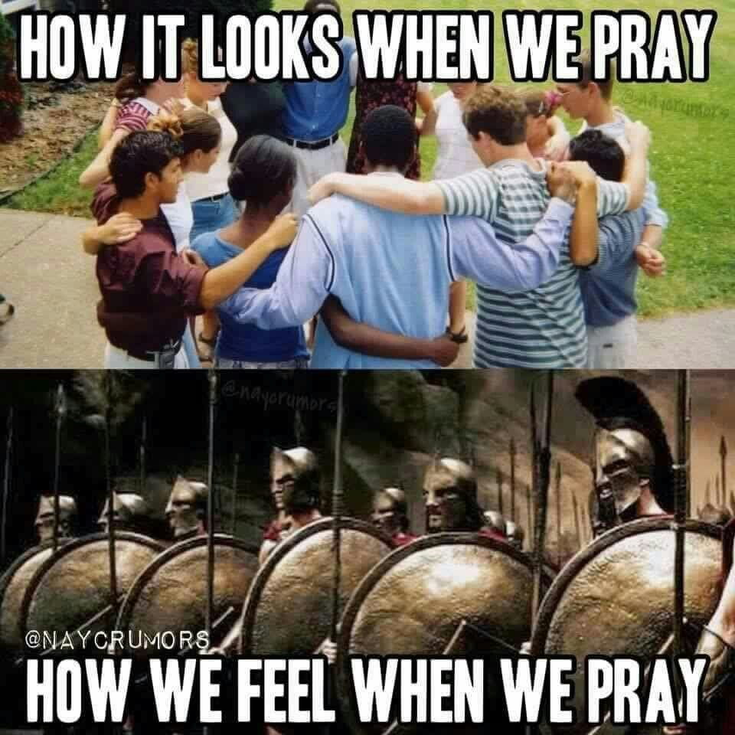

Evangelism is about teamwork
We need to work together, especially now, when things are getting worse in church decline...
The church is a team, we must all play together for the same side. In football what would you think if you saw the star quarterback take the ball to the wrong goal or tackle his own teammate? In the churches too often evangelism work (and other Bible-based work) is not undermined from the world, so much as from a preacher, elder, or brother. Remember we need to use our energies constructively to win in the spiritual challenges, we face. To do this we must be unified, not only in shared acceptance of a doctrine but in the practice of what it teaches, (love, selflessness, unity, peace, Bible-based service).
Energies are better used constructively to build up the kingdom in evangelism than in gossip, slander, and needlessly nitpicking the new converts and the people doing evangelism. Yet too often people would rather invest their time and resources in strife than for the works of love. The churches that grow will have people that are willing to work, despite the petty behavior of others. And blessed is the worker who does not have that in their local congregation.
Three kinds of people. Those who watch things happen, those who make things happen, and those who nitpick those getting things done. In the arena of life, it's those in the thick of it, that get stuff done. Marvelous stuff. Those in the bleachers only warm the seats they sit in as they talk soft platitudes. The lukewarm brethren will have to give an accounting. God will deal with such people, (Revelation 3:16). Pray for them.
The workers of the kingdom are those who are remembered, long after they are gone from this world. Those who dare to dream and dare to act, shall not be forgotten by heaven. Their names are within the book of life. Such people through their deeds build "monuments," in the heart, in how they touch the lives of those around them. Yet even as those who are touched fade from the pages of time...as life changes from age to age, know this...God remembers such service. The works may fade from the world of men, yet such deeds are historically recorded in His books. He never forgets.

------------------------------------------------------------------------------------------------------------------------------------------
Remember it’s a Process
Who here went to one college class and got their diploma the next day?
​Who here asked someone out on a date and got married the next day?​
Who here dieted and worked out, to lose weight and achieved their goal weight the next day?
These may sound like silly questions, don't they? To receive a diploma, you got to attend the college classes, you have to study, etc. You have put in the time, to get your degree. If you got a bad grade after your first semester, do you throw up your hands and say, "college does not work!" Of course not. College requires consistent and determined work to get the end result...that being a diploma.
To get married and have a family, you have to get into a relationship, and before that, you have to ask people out, right? If a person asked someone they liked, out on a date and were told "no," does that mean dating does not work?
Of course not, to get where you want to go, you have to keep doing the process. You have to give time (and emotional investment) to this desired work, to get the desired result.
If you went on a diet and went to the gym, then on the following day, when you’re up on the scale....to weigh the body, would you get upset... that your body weight goals had not been achieved? Of course not. Weight loss is a process. No one should say, "dieting and exercise do not work!" Like in anything in life, consistency, and deliberate long-term actions, are what make a difference.
This can be applied to anything. Think of examples. Nothing worth having tends to happen overnight. If a person wants a job, a family, friends, a skillset, a car, a home, etc. then certain things need to be done, as part of the process, for the desired end result to take place.
So why is it, that I have heard people say, "we went door knocking for one hour out of the year and no one was baptized, evangelism does not work!" If a person only does door knocking once in a year, at the 12th hr. before a gospel meeting, and is expecting results, they are not applying the same measuring lines onto evangelism, as they are applying on their own personal secular goals. Evangelism, like in anything else in life is a process. It requires time, energy, work to get the desired results.
------------------------------------------------------------------------------------------------------------------------------------------

View the work as a process. Invest in the process
The 3 Components for Success in matters of doing “event evangelism.”
In any evangelism work, one of three things needs to be done, to make it effective.
Frequency of events - the more events that are done the faster the results will come. If a church does an evangelism event once a year, that church will not get the same results as a church that does an evangelism event once a month. And a church that does evangelism once a week will get even better results.
Length of events - you can also choose to (instead) increase the amount of time given to each event to speed up the results. If evangelism group A works for 30 minutes for each of their once-a-month events, that group won't get as much headway as a group B which does 1 1/2 hour events once a month.​
Amount of workers in events - Another way to effectively hasten results (instead) is in the number of workers used. A team of 6 working in groups of 2, for an hour, won't get the same results as a team of 60 working in groups of 2. I've heard of 100 people doing door-knocking for a week and getting many Bible studies. Numbers can be useful.

------------------------------------------------------------------------------------------------------------------------------------------
It’s easy to sit on the sidelines
Silence requires nothing. No emotion, no message, no action. Silence will not offend, it will not be called "hateful," "mean" or "intolerant." Silence will not create enemies, lies, and unfounded rumors. If you want to be liked by most people, get along, keep silent. It’s not hard to do. Most people will do the same. But if you genuinely love others and care about people's welfare and their eternity, then you need to speak up. Share the gospel, warn of false teachings, rebuke sin, call evil, evil. Admonish, train, correct, that is how you truly show lasting love to others.
This may hurt feelings, but if others value God's truth more than what this sinful world has to offer then they will listen. Hell, and Heaven will come...someday. Are you going to remain silent? Judgment is coming. Are you going to sit and do nothing?
If you devote an hour to a specific area of growth, (like evangelism) a day or a year, you will grow according to the time invested. You will also impact others accordingly to the amount of time you set aside for such work. If in your lifetime, you invest little in kingdom building, you will only change things in small degrees. However, if you sacrifice...your time and devote your heart and your dreams to kingdom building, (working for God for a lifetime), you may just play a part in changing the world. You will also grow, (internally) by the hours you invest into a spiritual goal.
I know this to be true. A man or woman can grow in 5 years further than an evangelist of 50 years if they make evangelism, a "magnificent obsession." Google Tim Ferriss for a good example of a man who became a master at many skillsets in a short amount of time. He made one thing of singular focus and invested large amounts of time and energy to that main (desired) goal. Read up on this man to learn more. I personally have found this to be true. I have surpassed people (in a short amount of time) in secular and spiritual skillsets by making a specific goal my main focus and investment in time/energy.
How much a person is willing to do and is willing to become, is up to that person. I know a guy, (Jack Adams) who converted 100 people in one year. How did he do this? Jack did not do evangelism once a year, or every 6 months, or once a month, Jack looked for opportunities daily and acted upon those opportunities. Evangelism for Jack was a daily lifestyle practice. He tried to invite someone to a study or to church each day.

------------------------------------------------------------------------------------------------------------------------------------------

Final Resources: create your tribe and find sources of support
Find online and social places of inspiration and motivation. Find people to mentor you. Find sources of strength. I’ve included (below) resources that can help you motivation and growth. When I say “tribe” I am not talking about divided parties, at a congregation, as the word “tribalism” conveys. I’m referencing inclusion. Find people of like mind, work with them. Include others, incorporate mentorship practices by those you interact with. Have them mentor you. Find people who can encourage you to grow and develop in evangelism. Let your activities unite, not divide. Let them cause peace, not division.

Here are some helpful resources:
I encourage you to check out “Leading Others to Christ.” Dan Barker interviews some of the best evangelists around the Country. It is highly uplifting to watch these videos. https://leadingotherstochrist.org
Benjamins Lee’s PDF Book, “It’s Not Rocket Science.” Ben has created a study book that has helped his church to grow the principles in this book are powerful and can help the beginning evangelist. https://spiritbuilding.com
My evangelism platform. When you visit this site you can access training videos, books, and a training blog that includes some of the best advice from evangelists I’ve found. The Blog is called “blog insights” or “blog training.” www.churchofchristevangelism.com
Ricky Shanks helped me as a “mentor.” He may be of encouragement to you too. When Ricky was doing a Gospel Meeting in Tampa, FL I saved the recordings. The lessons are chock-full of exceptional/uplifting content. I have the audio files here if you want to download them and listen to the evangelism lessons Ricky taught.
1 Lesson: Building confidence and boldness.
2 Lesson: Reasons for ineffectiveness.
3 Lesson: Edify the new convert.
4 Lesson: Prayer.
Ricky Shanks is the Preacher at the Gainesville church of Christ Gainesville, GA
Website link https://answersfromthebible.org
He did an evangelism interview video you may like to see.
https://leadingotherstochrist.org/interview-with-ricky-shanks

------------------------------------------------------------------------------------------------------------------------------------------
Find your motivation: fan your fear of Hell.
Find Sermons: Most churches and most preachers don’t give sermons regularly on Hell and Heaven. In part that is why evangelism is received with a lackluster attitude. If people are not reminded of these themes, graphicly and regularly, then why should soul-saving matter. In the great awakening during the 1800s, sermons were centered around the themes of Hell and Heaven. The sermons were about God’s judgment and the seriousness of being lost. Nowadays sermons are not regularly focused on these themes. I encourage you to find sermons online that talk about these issues. Find sermons on Heaven and Hell. Listen to them often.
Exercise to fuel your excitement for Heaven and your fear of Hell. If you imagine in detail at night before falling asleep in bed, the visual aspects of Heaven. If you think about the greatest moments of your life and allow yourself to feel those past experiences and sensations. And say Heaven will be even better. If you think about what the Bible says about Heaven, and you imagine in graphic detail being there. If you can picture your happiest moments in life and know Heaven will be even better. Your fanning your excitement for Heaven.
If you think about Hell and those who love going there. And if you visualize in your mind (in detail) about what the Bible says about Hell and imagine being there, you’ll fan your fear of this place. If you think about the worst memories in your life, the greatest hurts and reflect Hell will be even worse, you’ll find your sources of motivation...for sharing Jesus. If you read scriptures about Heaven and Hell… during your time before bed, and picture what you read in detail. If you imagine yourself being there and those you love… then Hell and Heaven will become more real and the need to save others will become more strong.
------------------------------------------------------------------------------------------------------------------------------------------
Videos of Hell for motivation:
Letter from Hell: https://fb.watch/bDJ4iU35RD/
Portrait of Hell: www.youtube.com/watch?v=Rl1lzmx_UKs This is not my video, I uploaded it for personal use. You may find it intense.
Video about conviction:
The Apostles believed in Heaven and the gospel message so much as to be willing to die to share it. Would we do that for Jesus and for His evangelism work?: https://fb.watch/bDJ9Fq-H6p/
------------------------------------------------------------------------------------------------------------------------------------------
------------------------------------------------------------------------------------
Part 5: About the Author/ My goals in matters of evangelism
------------------------------------------------------------------------------------
Hello, my name is Joseph Sullivan. Thank you for reading this content. I know what I wrote is somewhat frank and intense. But the material is true, and it is important. I needed to share it.
We are here at a crossroads, what the saints choose to do will impact the kingdom in America for decades to come. Will we die out or will we survive and learn to thrive. That question is waiting an answer. Time will tell. We are here at such a time as this for action. This is our greatest hour in history and the challenge of our times. Will we step up or forever be remembered, (in the pages of heavens book) as the people who stood by as the US church slowly became extinct. It’s your time, this is your calling. All of heaven is watching. The cloud of witnesses are seeing us in the arena of life. What we do now will determine a revolution or a slow degrading death, (within the church). Let us act. Pray for guidance and God will send you messengers. People will come, angels will support, opportunities will arrive. Sources will be made available. Just believe, ask. Seek and you will find. Knock and the door will be open to you.

My goals in matters of evangelism.
My goal when doing evangelism was to learn for myself, to train my local evangelism team, but it went one step further, I wanted to record success stories, methods, resources to share with others. Themes to make people aware of the kingdom's pandemic of dying churches and to give them venues to change that. I wanted (through the Father) to give people hope. There are other platforms newer and far better than mine. And old forums that are affecting change. I am just one of the many instruments of Providence.
In any undertaking, business, politics, or group charities, it’s the minority, who step up to help with such work. In kingdom work within the universal church, it is no different. It will be the few who begin to step up. They will begin to affect the many. The few saints, (with fertile, ready hearts) will step up, once they learn of the need and are shown how to meet that need. All that is needed to change the kingdom is to reach the minority in the kingdom, who will have the minds to work. All they need is to first be shown the need for doing evangelism work and the "how-to" formats of outreach.
People need to be told and shown that evangelism is a moral responsibility. That the saved are here in this world with a divine purpose. We are here to save others as Christ saved us. We heard the gospel from someone’s mouth. We must be Jesus’ instruments to bring that same gospel to others.
My goal was to create a platform to show the need for evangelism and ways of doing outreach. A forum that gives hope and success stories. That goal has been met. Now I am promoting it on Facebook ads. I’m gearing it to those who FB “like” my (evangelism) page and to their friends as well. These geo groups are predominantly of the church. I also have another Facebook ad geared for many of the geographical areas in America near "COC Colleges." I researched where the colleges were online and picked on the Facebook's ad platform,(from the geo settings) those locations. Both strategies seem to work best in running ads.
My plans, I spent around 10 years collecting data. I have made a website, I am going to run Facebook ads every month for 20 years, making people aware that the churches are dying, that evangelism is not being done as it should, and that each one of us can make a difference. I will be promoting kingdom work in matters of outreach. I’ll be sharing facts in connection to our responsibility to this work. I’ll share themes that will encourage, as well stories, methods, thoughts, advice, etc.
If I reach enough people, and rain down this content in a steady stream, even the hardest parts of unyielding kingdom culture within the church, will begin to change in meeting this NT teaching. My hope is to see this change begin in my lifetime. I am just one of many people who are promoting these needed themes. Regardless, if I see change in my day or not, the pebbles will be cast, which will slowly begin the avalanche.
------------------------------------------------------------------------------------------------------------------------------------------Thank you for your love and passion. These traits you manifest. You’ve been reading this book. If you had no zeal for His house, you would not be reading my words to you, at this moment. You would instead be doing something else with your time. Your fire is valued and appreciated. May we burn for Jesus. May we burn bright. I pray God blesses you, strengthens you, and helps you in His service.
Much Love, Joseph Sullivan

